Spesen Skills

# Zusammenfassung

|  |  |
| --- | --- |
| Shop | Betrag |
| AliExpress | 3.36 USD → 3.34 CHF |
| LCSC | 25.57 USD → 25.42 CHF |
| Digikey | 60.30 CHF |
| Distrelec | 9.35 CHF |
| Zoll |  |
| JLC-PCB | 27.02 USD → 26.86 CHF |
| Total: | 115.90 CHF |

# AliExpress

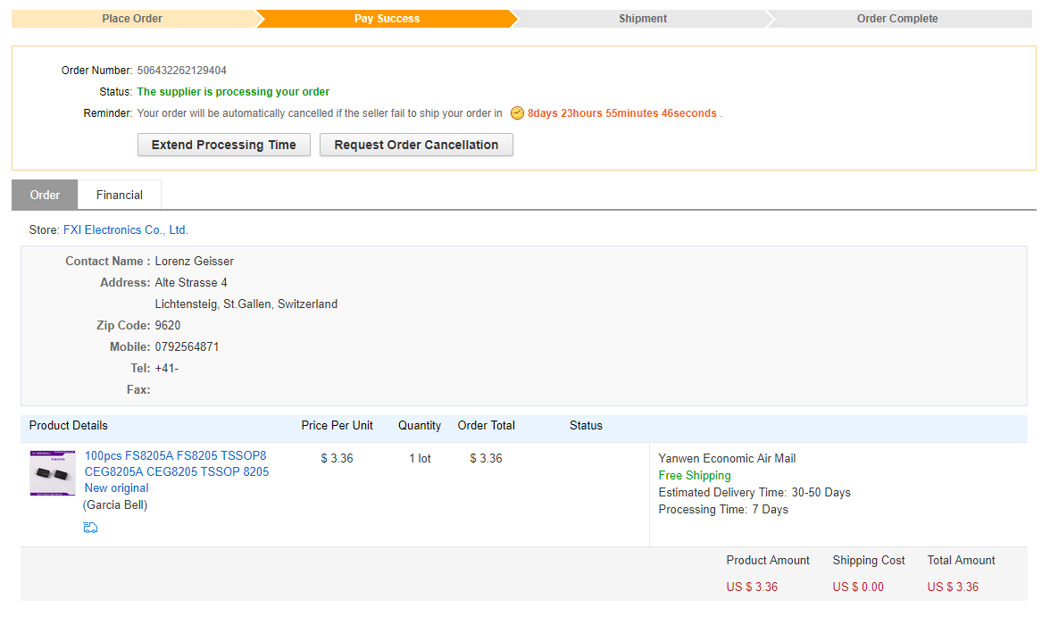

# LCSC

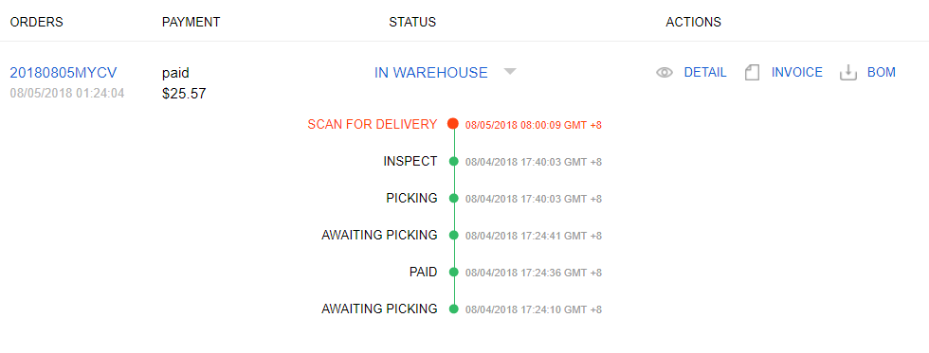

# Digikey

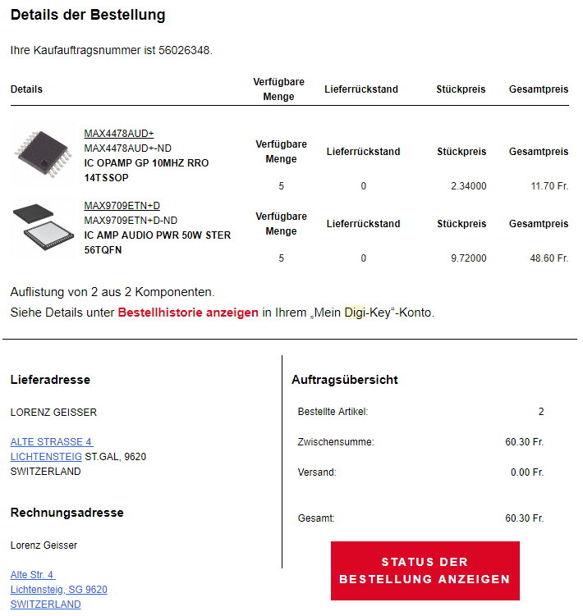

# Distrelec

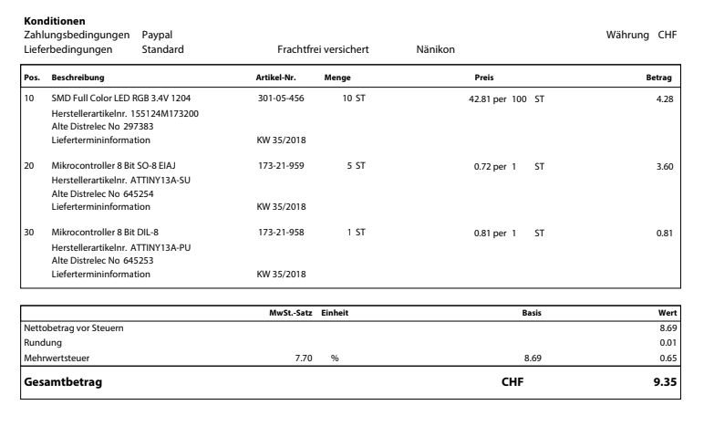

# JLC-PCB

